|  |
| --- |
| **PT. BERLIAN SISTEM INFORMASI** |
| **Operating Lease – Asset Selling** |
| **USER MANUAL GUIDE** |
|  |
| **bsi00357** |
| **10/24/2018** |

|  |
| --- |
| All material contained in this manual including text, graphics, icons and images contain proprietary and confidential information of PT. Berlian Sistem Informasi and are protected by international intellectual property and other laws. The compilation of all text, graphics, icons, and images in this Manual is the exclusive property of PT. Berlian Sistem Informasi. No modification, rental, lease, sale, transmission, distribution, reposting or creation or derivate works based on the material in this Manual is allowed, unless with the express permission of PT. Berlian Sistem Informasi. |

# REVISION HISTORY

|  |  |  |  |
| --- | --- | --- | --- |
| Date | Revision | Description | Author |
| 22/03/2018 | 0.0 | Initial Document | Sabilla Pravita Larassati |
| 23/03/2018 | 0.1 | Continue to translate all information from Bahasa to English | Sabilla Pravita Larassati |
| 09/04/2018 | 0.2 | Update information related to reports and changes after internal testing | Sabilla Pravita Larassati |
| 13/04/2018 | 0.3 | Add continuation of management reports and document hardcopy. | Sabilla Pravita Larassati |
| 24/10/2018 | 0.4 | Change detail in Manage Auction report process. | Sabilla Pravita Larassati |

# TABLE OF CONTENT

REVISION HISTORY 2

TABLE OF CONTENT 3

ASSET SELLING MODULE 4

1. MANAGE MEMO 4

1.1. List of Memo Pengajuan 4

1.2. Disposal Number Selection 7

1.3. Create Memo Pengajuan 9

1.4 Delete / Submit Memo Pengajuan 15

1.5 Memo Pengajuan Approval (in / off system) 16

1.6 Input Auction Result 17

1.7 Payment receive process in OLSS 19

2. MANAGE REPORT 21

2.1 Checking and Sign laporan hasil penjualan 23

# ASSET SELLING MODULE

Asset selling module is a new module in the Operating Lease Support System Phase 3-4. This module is integrated with MFAPPL because some of the data can only maintain in MFAPPL such as asset master data. With the new asset selling module, PIC OPL able to manage asset selling starts from memo pengajuan creation based on offered price from the customer, gain/loss calculation, and print document report (hardcopy or softcopy).

Asset selling process starts with the selection of assets that will be sold. This process is done in MFAPPL. Chosen data will be sent to OLSS using a scheduler that operates every 10 minutes. When selecting an agreement number and asset code in MFAPPL, please make sure the data is accurate and valid. Because if there's some mistake, PIC OPL has to wait for the data to send to OLSS, then cancel it.

# MANAGE MEMO

Creating a memo pengajuan is done in OLSS. After agreement and asset code has been chosen from menu Asset Selection in MFAPPL, and data has been received in OLSS using the scheduler, PIC OPL able to starts creating memo pengajuan. Managing memo in OLSS divided into some functions:

1. List of memo pengajuan
2. Disposal number selection
3. Create memo pengajuan
4. Delete/submit memo pengajuan
5. Memo pengajuan approval
6. Input auction result
7. Payment receive in OLSS

## List of Memo Pengajuan

List of the memo will display all types of memos created by PIC OPL. Used by PIC OPL to monitor memo progress and memo status. Here are the steps to access List of Memo Pengajuan:

1. Open application OLSS using a browser (IE/Chrome) with link http://192.168.140.21/olss2.
2. Login using username and password as PIC Admin OPL.

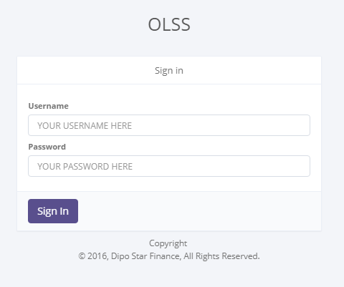

Figure 1: Login OLSS Page

1. After opening OLSS homepage successfully, navigate to Asset selling menu and pick Manage Memo.

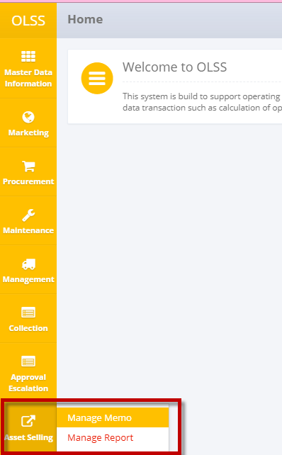

Figure 2: Navigation to Manage Memo

1. The system will display Manage Memo Approval:

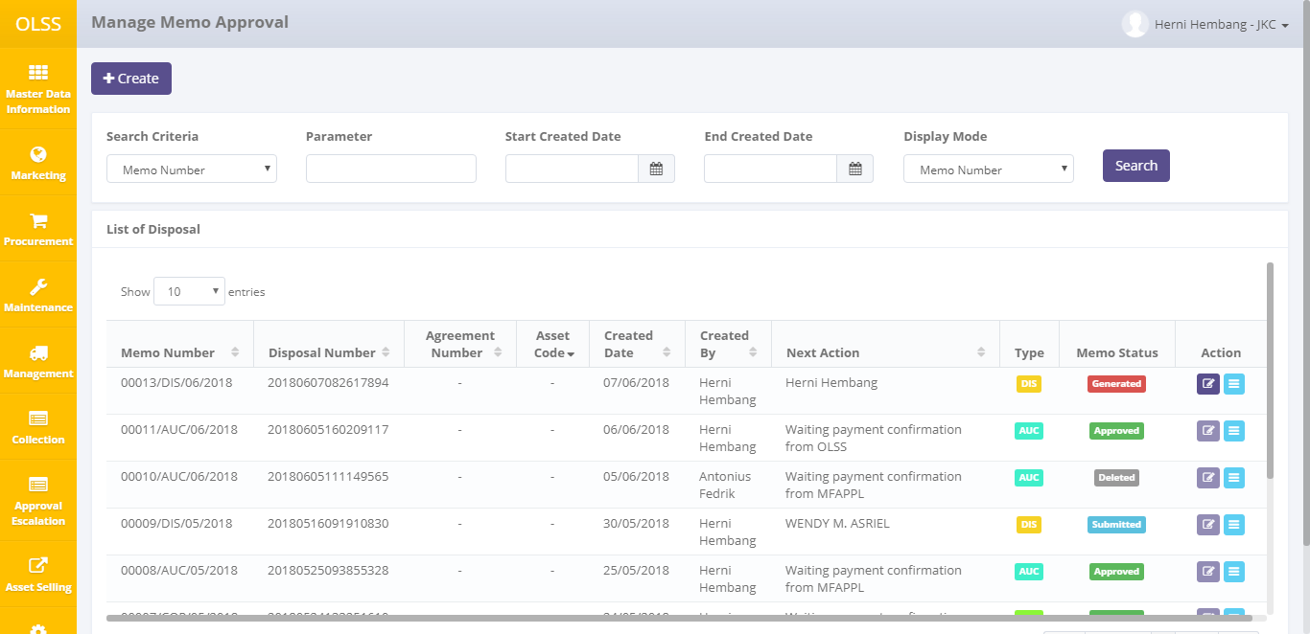

Figure 3: List of Memo Pengajuan Page

PIC OPL able to see information such as:

1. Memo Number: generated automatically after memo created, at least status Generated.

Format memo number is: XXXXX/DIS/MM/YYYY (XXXXX is running number, DIS is memo type, MM is a month, YYYY is a year)

1. Disposal Number: generated number from MFAPPL after asset selection.

Format disposal number is: YYYYMMDD and random unique number

1. Agreement number: contract number, only visible if Display Mode is changed to Agreement number and Asset Code
2. Asset Code: only visible if Display Mode is changed to Asset Code
3. Created Date: memo creation date
4. Created by: username of memo creator
5. Next action: the next activities for the current memo, for example, the name of the approver, or waiting for payment confirmation.
6. Memo Type: display memo pengajuan type, there are three:

* COP: Car ownership program
* AUC: Auction
* DIS: Direct Selling

1. Memo Status: asset selling status divided into 10 types:

*  means PIC OPL has saved the new data or save changes in memo detail.
*  means memo is saved temporarily and still able to be changed.
* , means document has been submitted by PIC OPL, unchangeable, and ready to be checked and approved.
*  means there's still some correction needed and the document is sent back to memo creator with notes. Document need to be submitted back by PIC OPL.
*  means memo has been approved by DSF management.
*  means memo has been rejected by DSF management or creator. The disposal number can be recreated using a different type of memo
* , means payment receive has been done for all unit in the memo.



* , means all asset has been sold and BPKB has been released.



*  means the memo has been deleted. The disposal number will be sent back to MFAPPL

On the list of Memo Pengajuan page, there are 3 buttons:

* 1. : On the left-up page, click the button to create memo pengajuan.
  2. : On the action column in each row, click the button to view memo pengajuan detail.
  3. : On the action column in each row, click the button to change memo pengajuan information. The button only active for memo with status Generated, Draft, Revised.

To sort and filter memo, there are three categories:

1. To sort the data by word column, user able to click  on title column on table header.
2. User able to pick total data displayed by choosing feature  on screen. If data is filtered by entries, then data will be displayed as many as number entries.
3. User able to filter data by inputting keyword in parameter field and choosing criteria as follow:

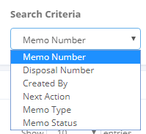

Figure 4: Search Criteria

To get a specific result, the user also able to limit the memo creation date (Start Created Date and End Created Date).

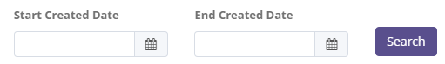

Figure 5: search by Date limit

Change Display Mode to enable Agreement Number and Asset Code in Index.



Using this feature, the user doesn’t have to view detail on every memo to check the agreement number or asset code. If the Display mode is changed to Agreement number and Asset code, memo number will be split according to asset code and agreement number contained.

## Disposal Number Selection

To start creating memo pengajuan, the process starts with disposal number selection. Click Create button on top-left of the List of Memo Pengajuan Screen.

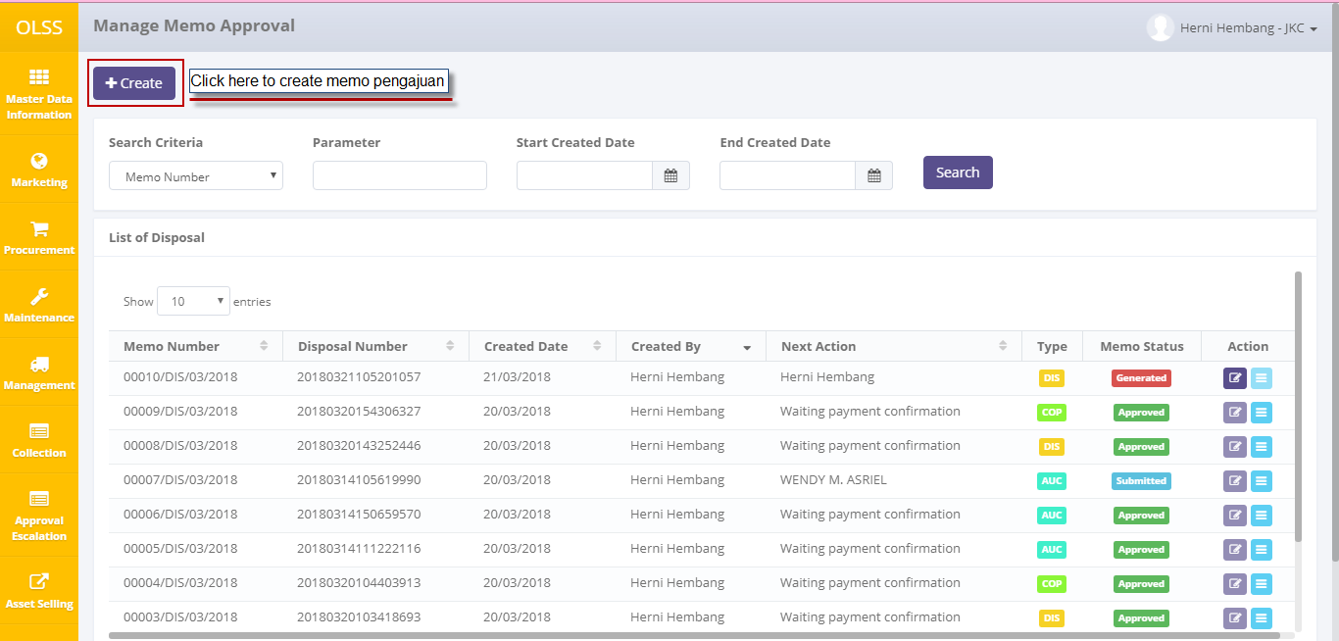

Figure 6: Create Memo Pengajuan button

The system will display the Disposal number selection screen as follow:

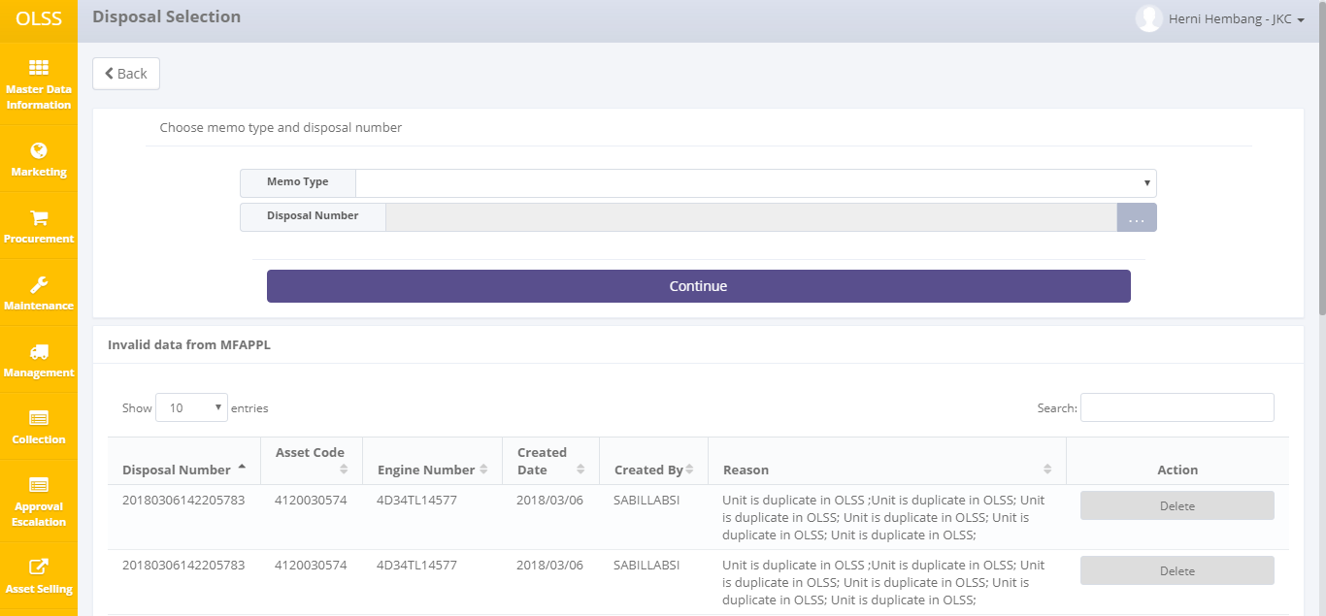

Figure 7: Disposal Number Selection screen

At the lower screen, there are invalid data displayed that can’t be processed in OLSS. These data will be displayed on the table if:

* 1. Agreement number can’t be found in OLSS
  2. Engine number can’t be found in OLSS
  3. Agreement number found a duplicate in OLSS
  4. Engine number found a duplicate in OLSS
  5. Customer name can’t be found in OLSS

To fix data above, please contact your ITD support. After data has been fixed, data will be valid and able to be processed in OLSS to create memo pengajuan. If the disposal number will not be used in OLSS, click Delete button to send back the asset to MFAPPL.

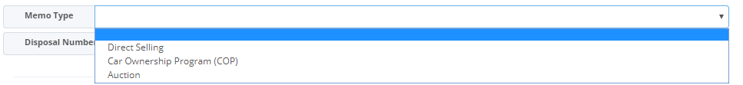

On Memo Type, PIC OPL able to choose memo type:

1. COP: asset bought by the customer on the contract, or by the recommended person by the customer on contract.
2. DIS: the asset is offered and bought by a person other than the customer on contract.
3. AUC: assets are auctioned off in the auction hall

After choosing memo type, the next is choosing the disposal number that has been inputted in MFAPPL.

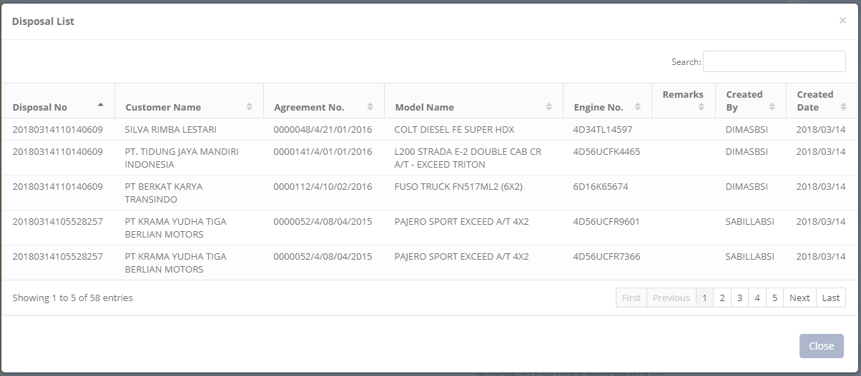

Figure 8: Disposal Number Selection Screen

List of disposal number will display information such as disposal number, customer name, agreement number, product name, engine number, remarks, created by, and created date, based on data that has been chosen and sent from MFAPPL. PIC OPL only able to process one disposal number per memo. After disposal number and memo type are chosen, click the Continue button to process the next step.

## Create Memo Pengajuan

Memo pengajuan screen will be different based on the memo type. Here is the screen of three memo types with description.

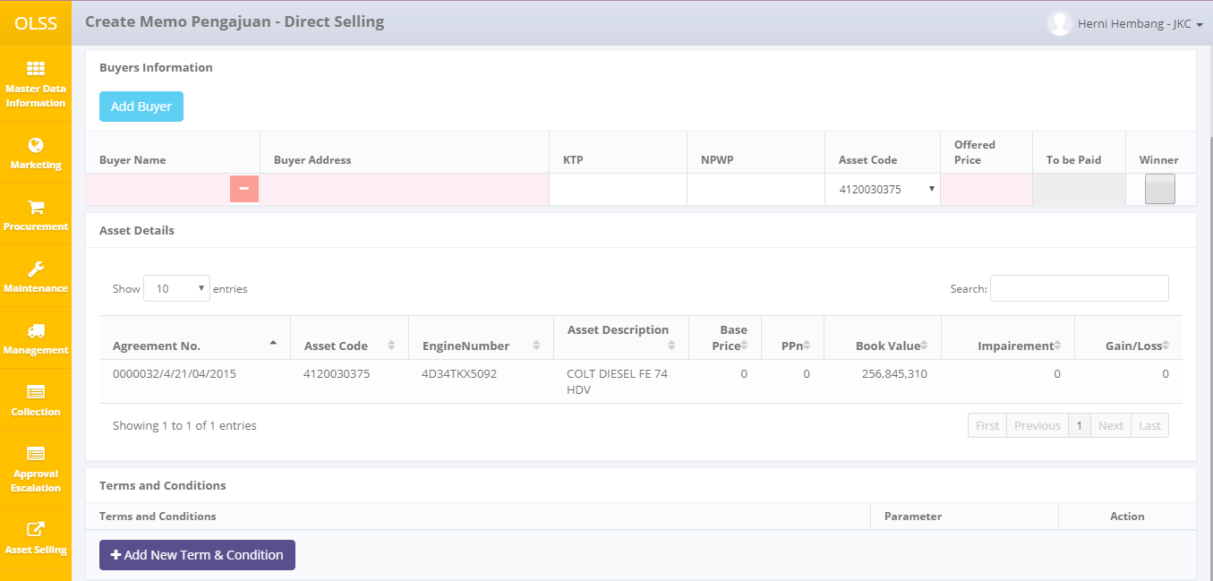

Figure 9: memo pengajuan – DIS screen

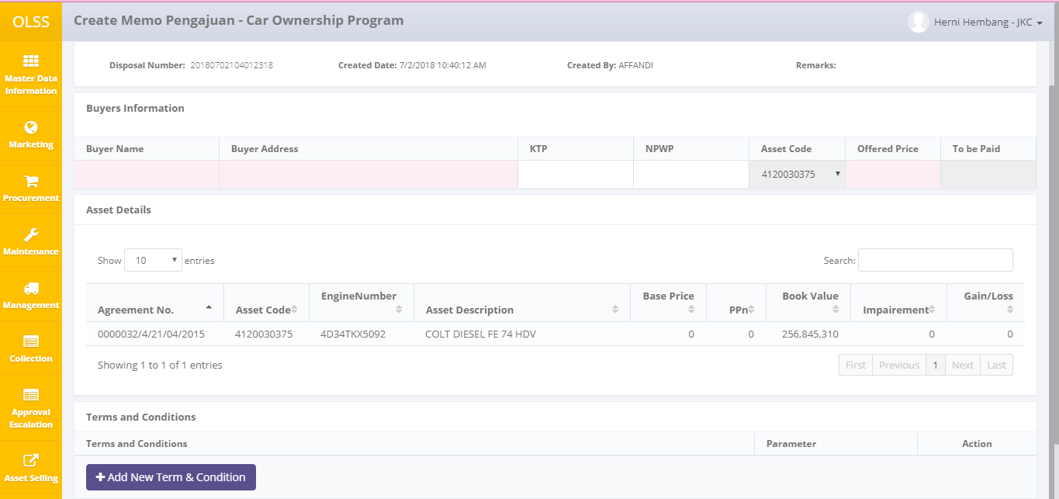

Figure 10: memo pengajuan – COP screen

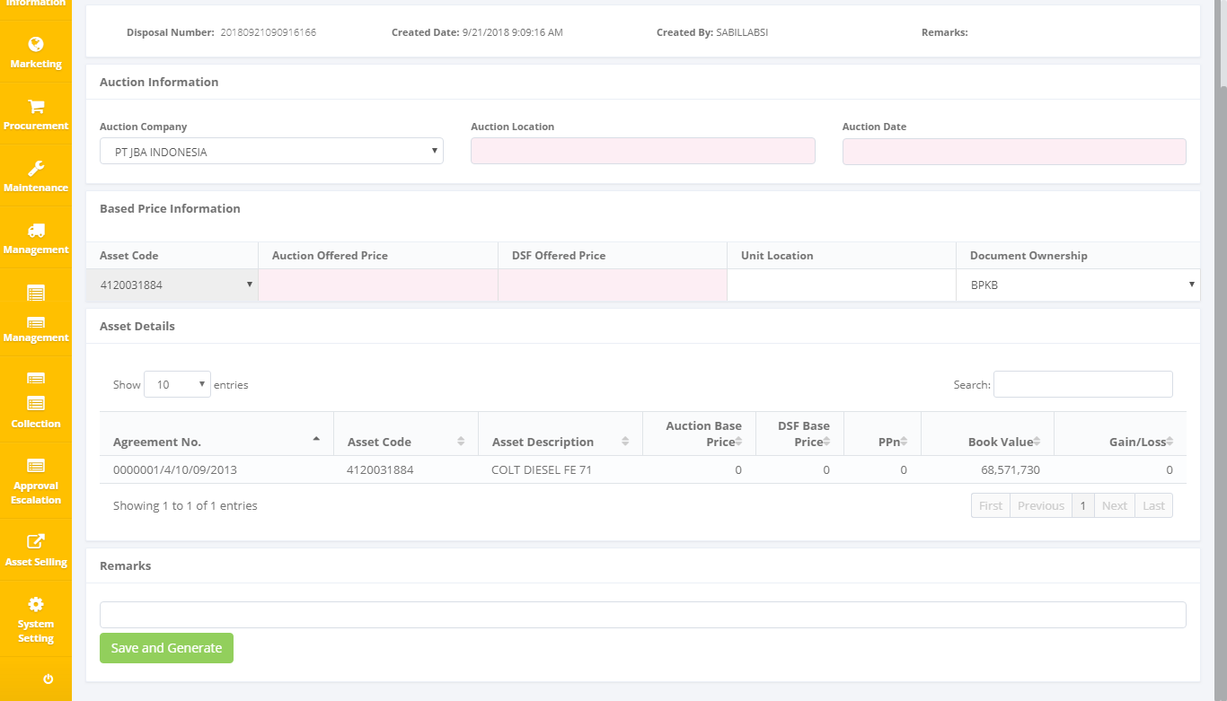

Figure 11: Create memo pengajuan – AUC screen

For memo type COP and DIS, on the top section, there is buyer information. PIC OPL needs to fill buyer name, buyer address, KTP/NPWP (if available) and offered price for each asset. To Be Paid column will automatically calculate purchase price and Ppn 10%. For DIS type, PIC OPL has to manually add buyer information who bid the assets. Then PIC OPL will choose the winner based on the highest price or management recommendation.

For memo type AUC, on the top section there is auction information where PIC OPL has to fill Auction Company, auction location, auction date, Auction Company recommended price, DSF offering price for each asset, and current unit locations.

In the middle section, there are asset details like agreement number, asset code, asset description, base price, Ppn, book value for the current date, impairment value, and gain/loss value. The column that filled is only the book value. Another column will be displayed after PIC OPL saved the offered price offered by the customer.

After that, there is a profit analysis result showing contract number, asset name, asset year, asset amount on SKD, profit based on initial budget, an asset to be sold, and estimated profit after the sale. Next, there is a field of remarks that can be filled by PIC OPL records before saving the filled data.

At the bottom, there is Term and Condition section (only visible in memo type DIS and COP). Term and condition feature used by PIC OPL to input condition in each case of asset selling. Click  to add a new row of Term and Condition. Click  to pick any term and condition that has been inputted and changed the value/parameter based on each asset selling case.

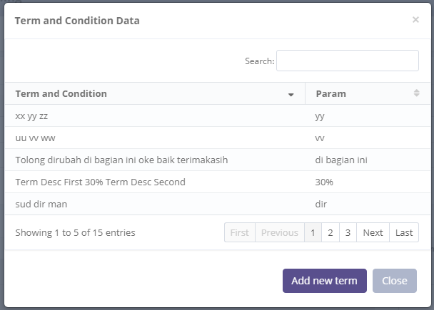

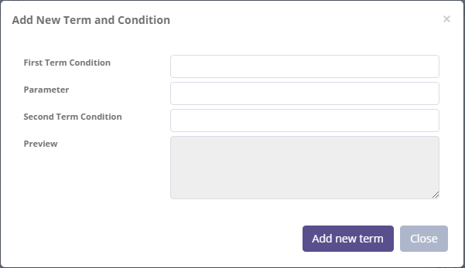

If PIC OPL wants to add a new Term, click  then fill the information:

* First Term Condition: input the intro message
* Parameter: input the important value/parameter (which can be changed when used in a different case)
* Second Term Condition: input the outro message.
* Preview: to check Term and Condition message result.
* Add new term: to submit the Term and Condition to be used.

After all, information has been filled, click/button to save data and display profit/loss calculation.

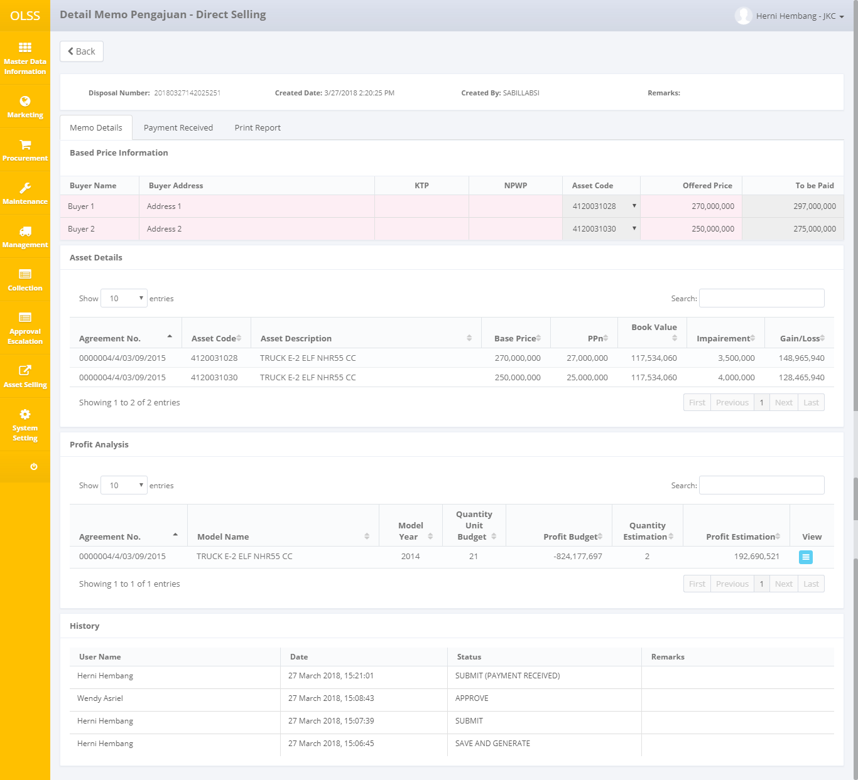

Figure 12: gain/loss calculation display after saving and generated

After the data is stored/saved, the system will calculate the amount based on the offered price, amount of expenses, and book value. In the middle, the details of the assets will display the base price in accordance with the purchase value, VAT takes 10% of the base price, the book value of MFAPPL, the impairment of MFAPPL, and the previously empty profit/loss.

At the bottom, will show the value of profit/loss estimates based on expenditure inputted in MFAPPL. PIC OPL can view and change its details by clicking the Edit profit Analysis button.

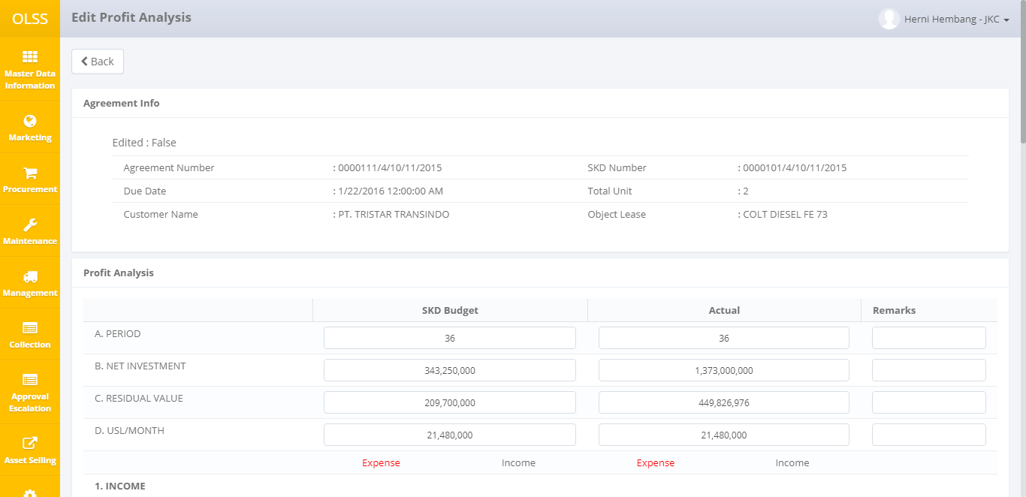

Figure 13: profit analysis screen - up

At the top, there is contact information such as contract number, contract start date, customer name on the contract, SKD number, the total unit sold, and the name of the asset product. Furthermore, there are two parts below the SKD budget and Actual. SKD budget is the initial budget when making SKD, while Actual is the actual SKD expenditure. If the assets sold are only a few (not all assets listed on the SKD), then the system will calculate the SKD budget with Prorate. The actual calculation is calculated by the total sum. Multiple fields can be changed due to the possible difference between OLSS and MFAPPL data.

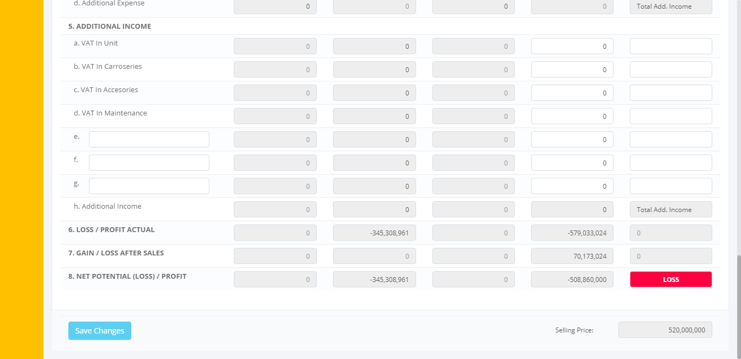

Figure 14: Profit Analysis - bottom

Net potential will display LOSS if profit <0, and will show PROFIT if profit> 0. Selling price will display the total purchase on the contract. After the data has been changed, click the Save Changes button on the bottom left. Then the system will return to the Memo Creation screen.

## Delete / Submit Memo Pengajuan

Furthermore, PIC OPL can select the following button:

1. , delete the submission memo and return the disposal number to the MFAPPL. Used when there is a contract replacement or asset code.
2.  deletes the memo of submission so that the disposal number can be reused. Used when PIC OPL wants to change the memo type.
3. , store asset data. Used when there are changes to inputted data such as name and price.
4. , save the temporary submission memo. Memos can still be changed.
5. , submit a submission memo for management approval

If the PIC OPL chooses to delete ()the memo due to an incorrect contract number or asset code, then the data will be removed from OLSS and sent back to MFAPPL. Furthermore, PIC OPL can re-select contract number and asset code in MFAPPL through asset selection menu.

If the PIC OPL chooses to Reject the memo due to incorrect memo type, then the memo number will be deleted in OLSS and can be re-selected in Memo Creation.

If the PIC OPL stores temporary data (), then the user can change the data again by clicking the following button:

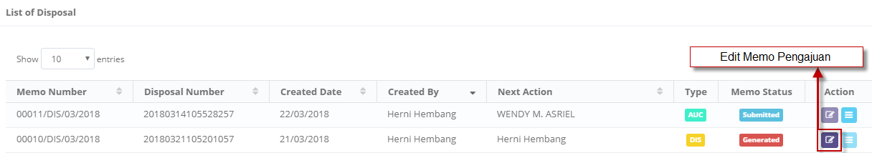

Figure 15: edit memo pengajuan button

If the PIC OPL has finished creating or changing a submission memo, PIC OPL may submit the memo ()for management approval.

## Memo Pengajuan Approval

There are two types of approval, inside and outside the system. Outside the system, PIC OPL should print a submission memo and profit analysis document through View Detail Memo File:

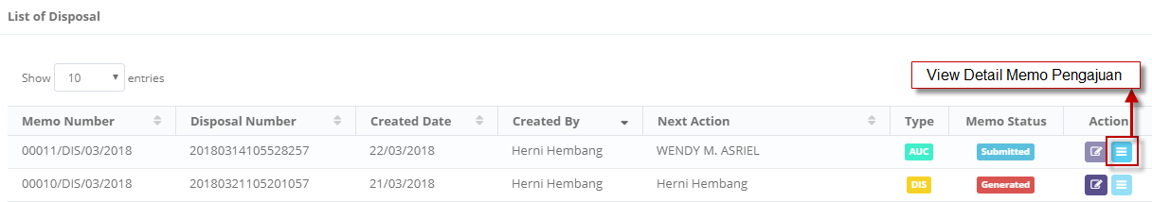

Figure 16: view detail memo pengajuan button

Click tab Print Report.

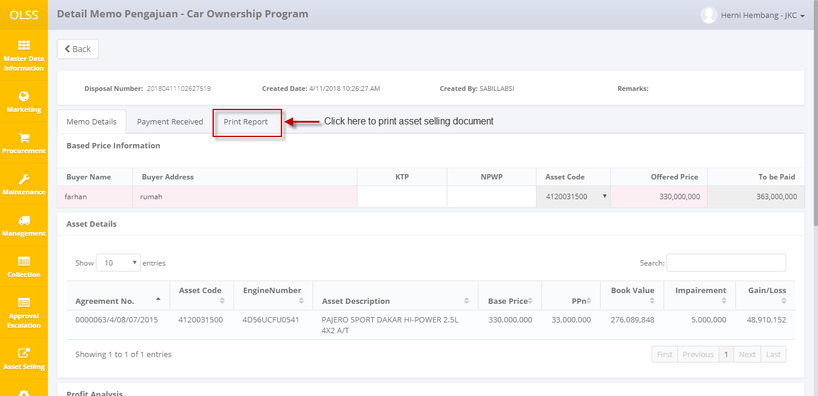

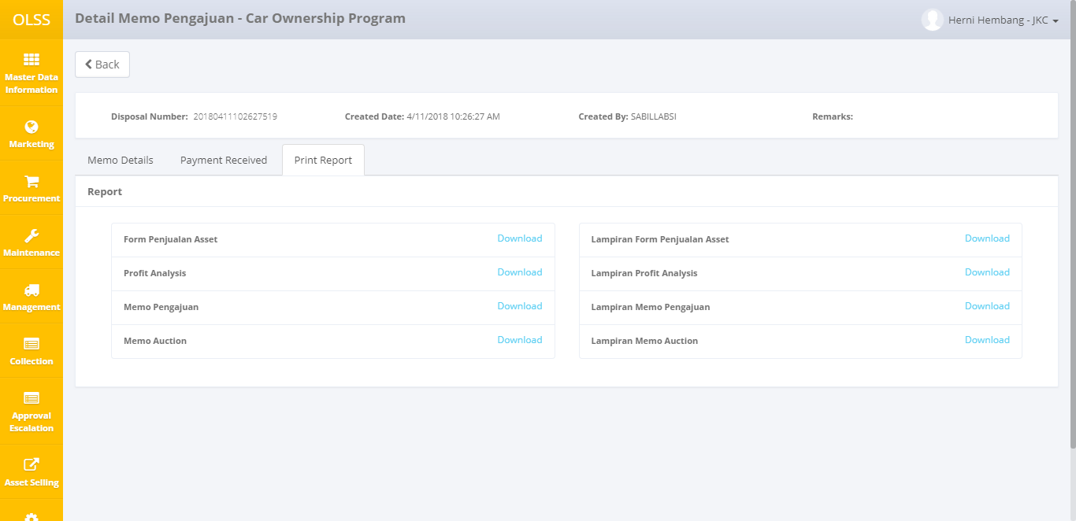

Select Download on a document that wanted to be printed. And the system will display document preview. Click save button on top of the screen to download the document in PDF or EXCEL before printed.

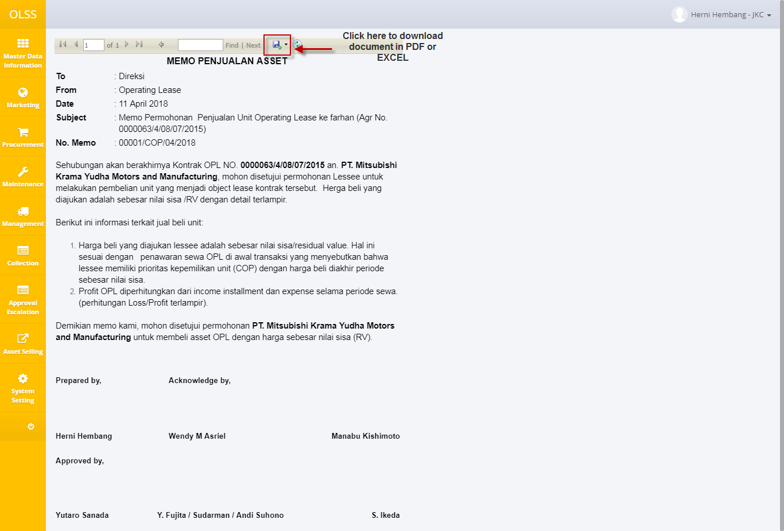

In the system, once the memo pengajuan is submitted, the PIC OPL can find out the next action in the "Next Action" column. The "next action" column will show who will approve the memo. To approve the memo, Log Out from the current role, and Login using the username for management. Once successfully logged in, go to the memo submission list and select View Detail Memo Pengajuan.

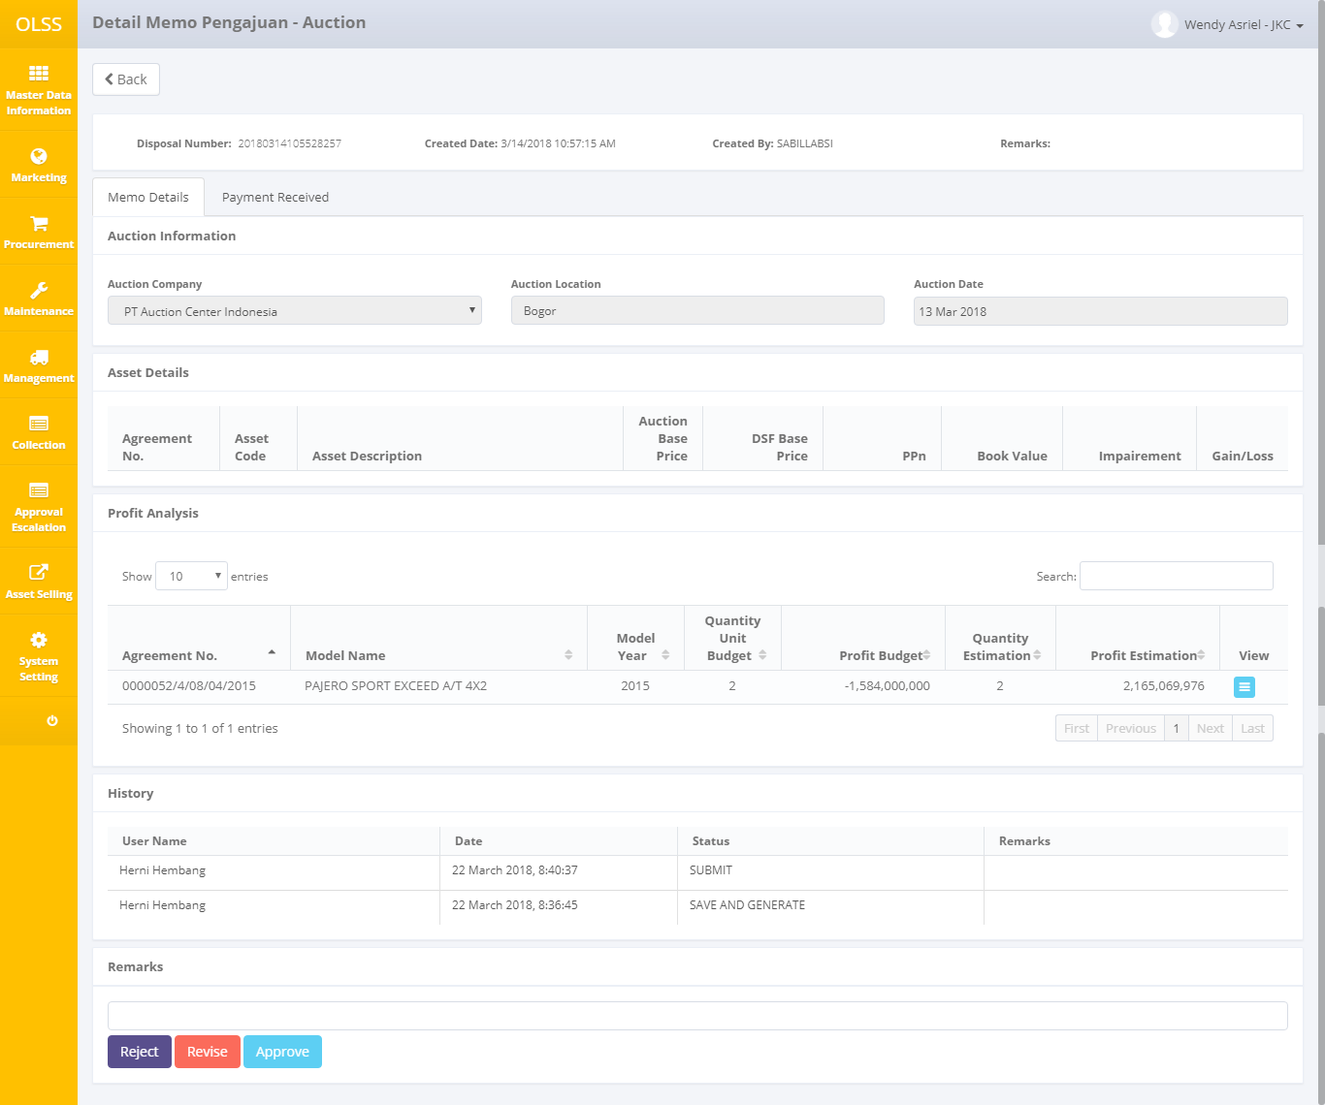

Figure 17: memo pengajuan screen for approval

At the bottom of the screen there are 3 choices of buttons, namely:

1. , the memo is rejected for some reason and returned to the submission memo maker.
2. , the submission memo is returned to the memo maker as there is something to be corrected.
3. , the memo is approved and returned to the submission memo maker.

## Input Auction Result

Once the memo is approved, User will begin to process sales activities outside the system such as auction and signing documents between two parties. For auction type, after the auction is completed, PIC OPL will input the result through Memo View Detail on memo with AUC type. Find the memo with memo status Approved, and next action is “Waiting for payment confirmation from OLSS”.



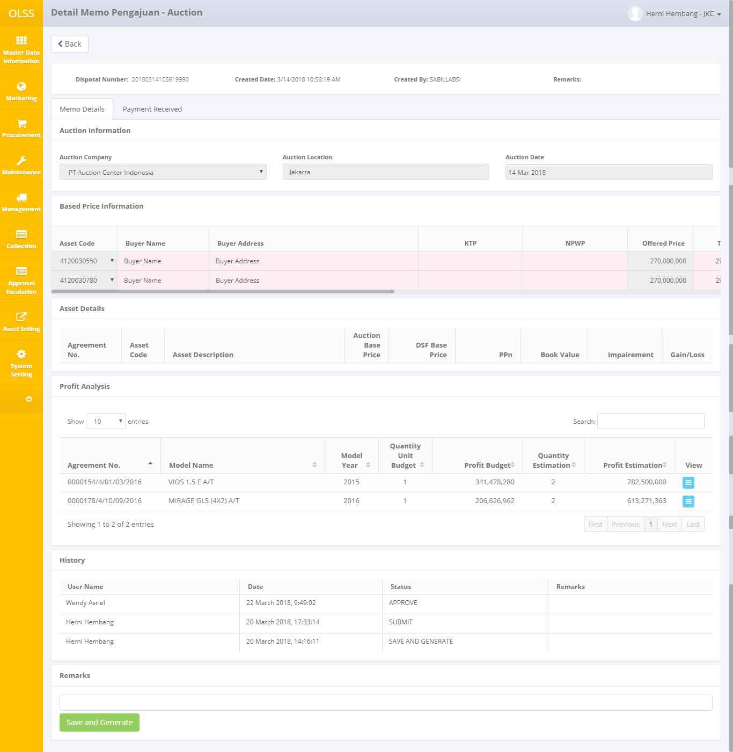

Figure 18: memo pengajuan screen– AUC after memo approved

PIC OPL must fill in the buyer's name, buyer address, no ID, no NPWP, total sales, auction fee, mobilization fee, ppn, pph, unit location, and document ownership. Next, click the save and generate button to save the data.

## Payment receive process in OLSS

After the submission memo is approved, the auction results have been inputted, and important documents have been signed, then the next process is to input the receipt of money from the buyer. To perform the process, PIC OPL can access it through View Detail Memo Pengajuan on Payment Receive tab.

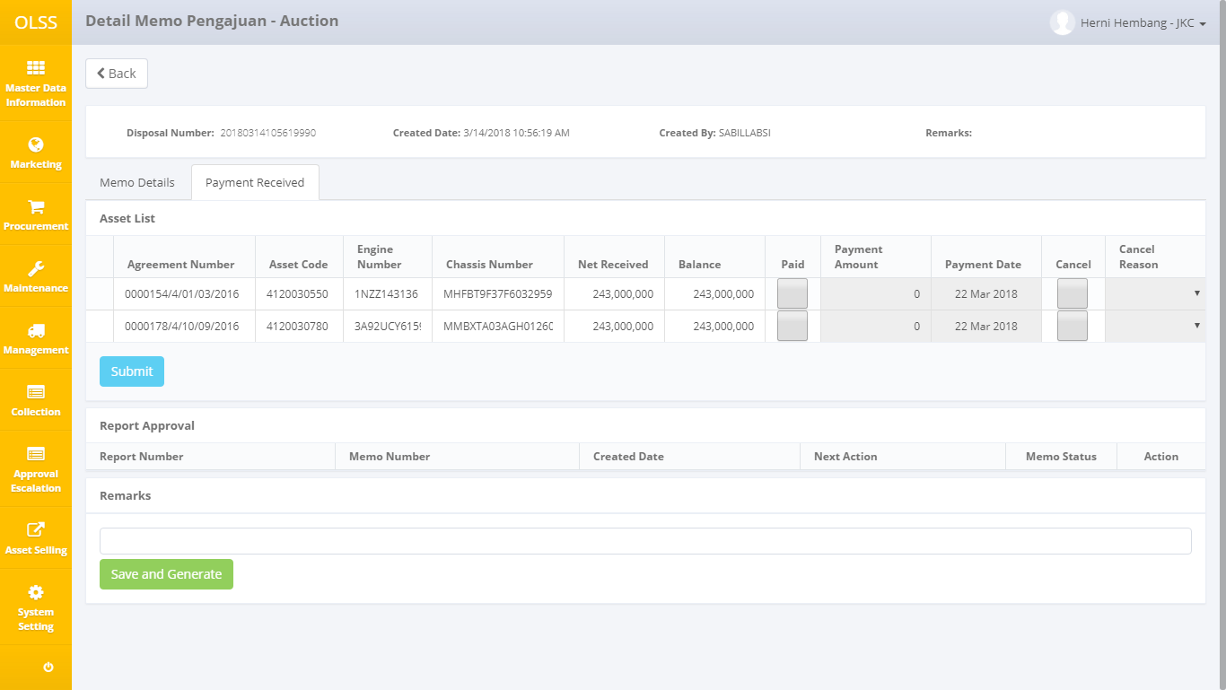

Figure 19: payment receive tab screen

In this section, the PIC OPL can input sales if there is already a cash receipt or a purchase cancellation. If there’s any receipt of money, PIC OPL can choose a PAID box. Each asset will show the fees to be paid, for COP and DIS types, the paid amount should be equal to the stated cost (if more, a warning message will appear) and may be paid partially / in installments per asset. As for the AUC type, it cannot be paid partially / in installments per asset.

In the event of any cancellation of the asset sale, PIC OPL may choose Cancel and fill in the reason for cancellation. The canceled asset will be returned to MFAPPL in order to be re-selected.

Click submit button to save the payment. After the PIC OPL inputs the receipt of money in full, the system will generate a Sales Results Report (only formed when the payment is fully paid in one or all assets) with status Created. After payment is submitted, OLSS will send the information to MFAPPL. In exception for Auction case, after submitting the payment (all assets or only one asset), the report will not be created automatically, because the user will have to select memo manually to be combined in one report.

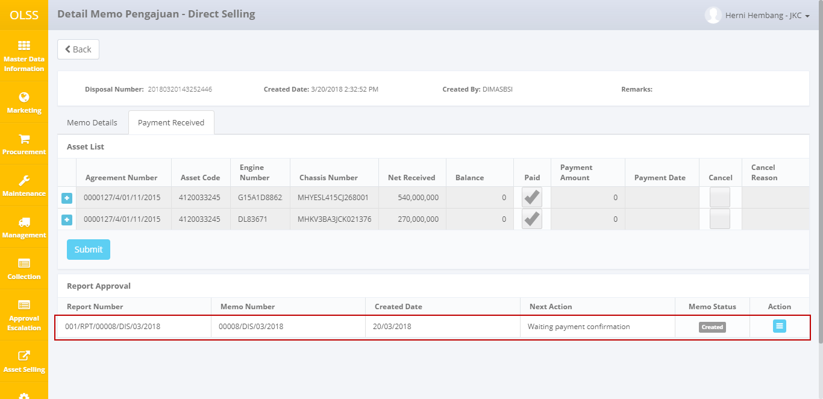

Figure 20: create laporan Hasil penjualan screen

After the report created, click the view button on the action column, and the system will display the details of the Sales Results Report.

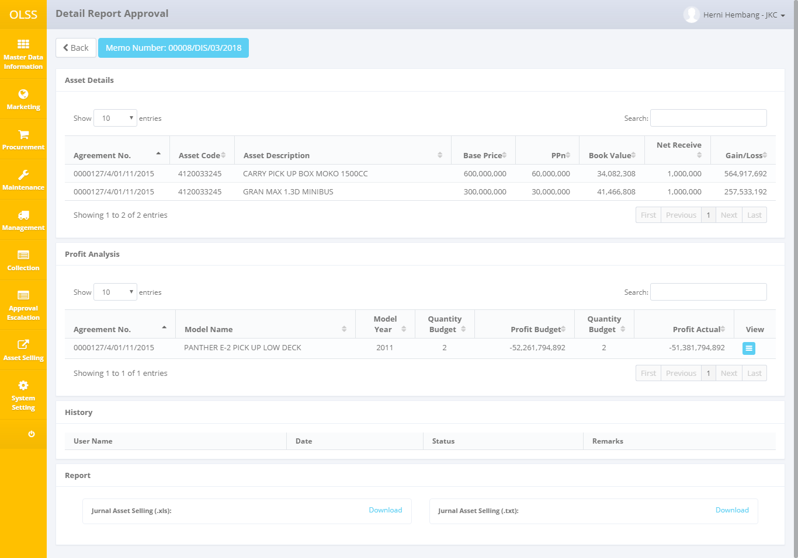

Figure 21: detail laporan Hasil penjualan

At the top, there is the memo number information, which makes it easy for PIC OPL to return to the initial memo.

# Manage Report

The system will form a sales report for each process of payment receive in OLSS. This report can be viewed through the asset selling menu → manage report.

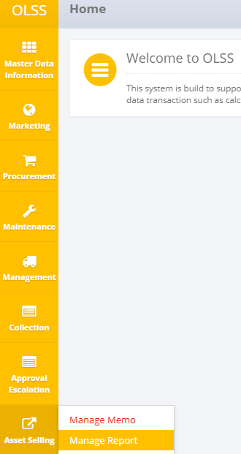

Figure 22: navigation to manage report

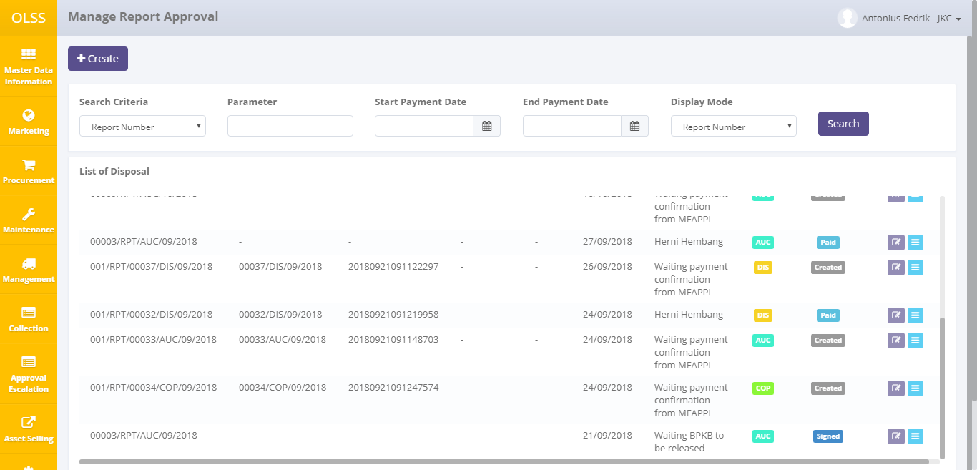

Figure 23: list laporan Hasil penjualan screen

The information displayed in the Manage Report Approval is similar to the information in the Manage Memo Approval. The difference lies in the report number information and the report status.

Report status consists of:

1. : Sales report has been established, and waiting for the journaling process in MFAPPL.
2. Paid: payment has been done in MFAPPL, and the report is ready to be checked by PIC OPL.
3. Checked: Reports have been checked by PIC OPL and submitted to management.
4. : Management has signed the sales report.



1. Closed: assets are already sold, and BPKB documents have been released.

For information next action consists of:

1. Waiting for payment confirmation from MFAPPL: awaiting the process of receiving money in MFAPPL, starting from payment transaction, journaling, until posting data.
2. Waiting Asset and BPKB to release: awaiting asset sale and release of BPKB document.

On the list of Manage Report Approval page, there are 2 buttons:

1. : On the left-up page, click the button to create report Auction.
2. : On the action column in each row, click the button to view report detail.

For AUC memo type, the report created after submitting payment received in OLSS will not be automatically sent to MFAPPL. The user has to create the report by clicking on the Create button.

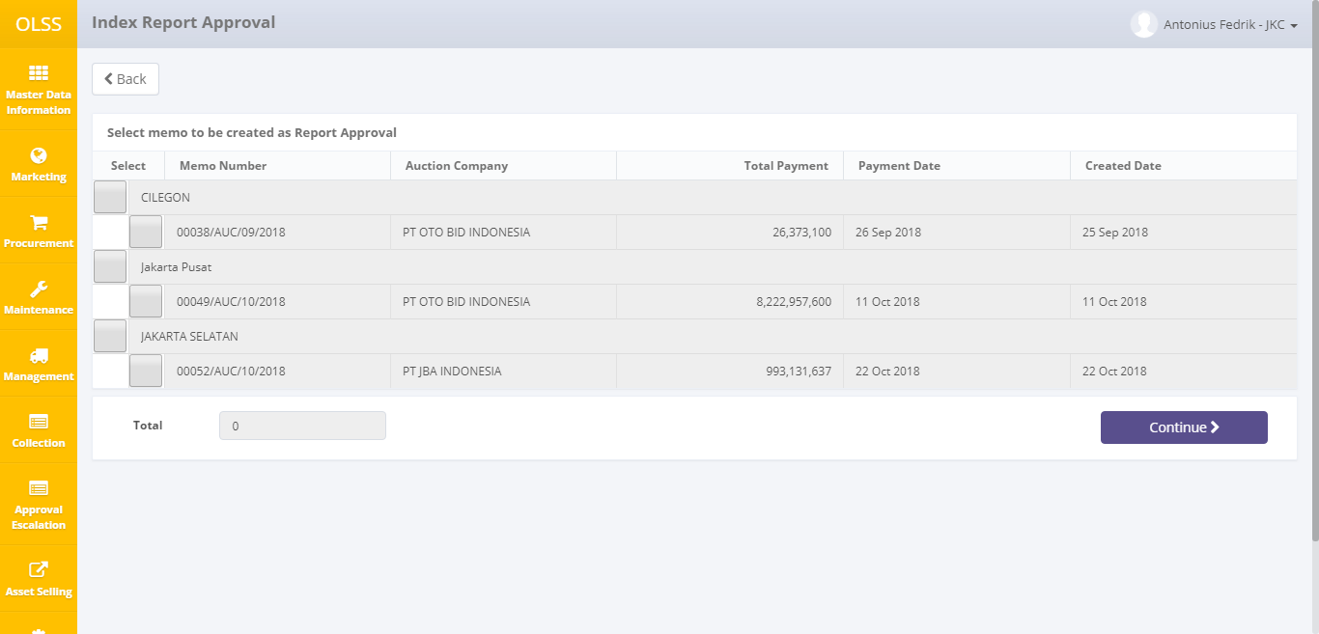

User able to select memo based on branches and auction location. There is information about branches, the auction company, memo number, total payment, payment date, and created date. At the bottom, there is total payment for selected memos. The memo is sorted by payment date. Click continue to process the selected memo.

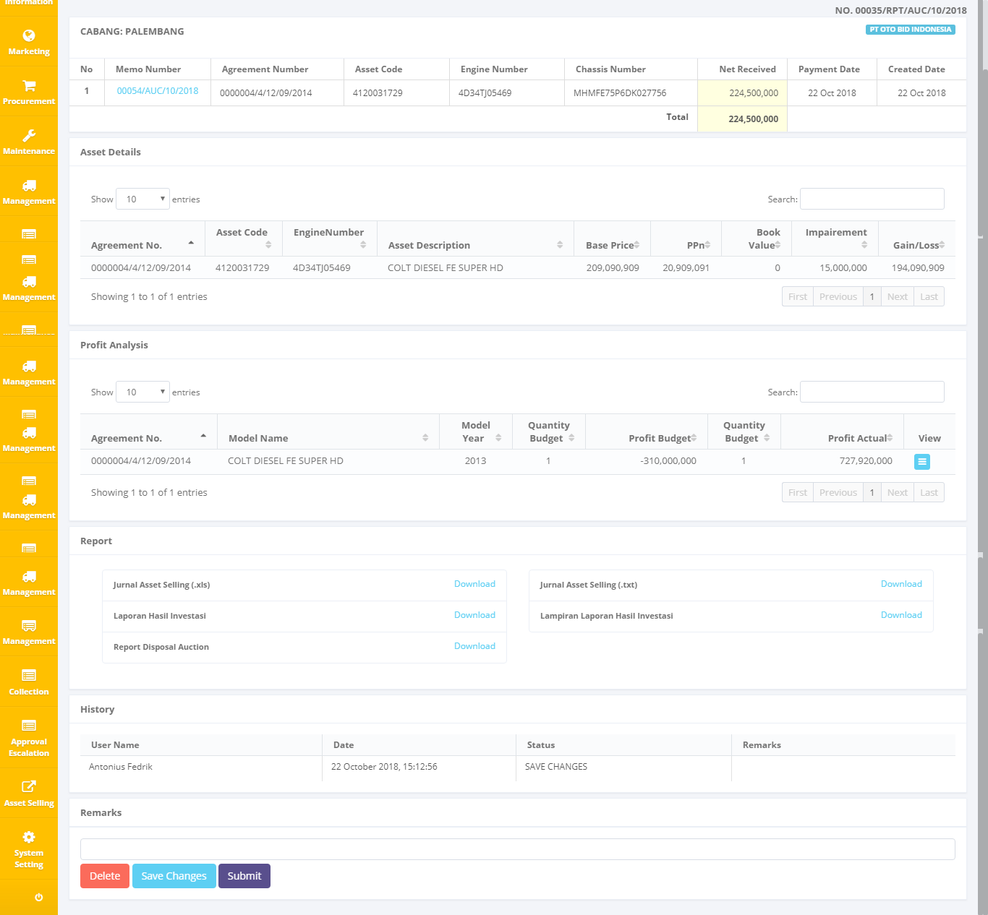

On the top section, user able to see branches, report number, the auction company, and auction detail information. The net received field is able to be changed, in case there is miscalculation between OLSS and MFAPPL when payment has been received in the bank account after the auction is done.

There are three buttons at the bottom of the page :

1. , the report that has been processed after clicking “continue” will be deleted. Memo able to be selected again in report creation.
2. , save the report as a draft, and able to be changed.
3. , report information will be sent to MFAPPL to be processed in payment. Report status will be changed to Created.

## Checking and Sign Asset Selling Report

PIC OPL can proceed to the process of checking the sale after the status of the report changed to Paid. To process the check can be done through the View Details:

The contents of a sales report are similar to a Memo Pengajuan. The difference lies in the book value of the month that may change when processed through the month, and each asset are spending costs that may change after specific activities. PIC OPL can shift profit analysis, and check reports before submitting to management. To review, select the Check button at the bottom:

The system will return the view to the list of sales reports with the status of the memo is changed to Checked. The statement will then sign by the management listed in the "next action" column.

Continue the approval process such as the approval step of the submission memo, and the status of the report will change to "Signed."

Once the management approved the report, PIC OPL can continue the sales process by downloading the sales data: template asset selling expense that will upload to MFAPPL. Download sales data can access through View Details. At the bottom, there are options to download the files in excel and textfile.

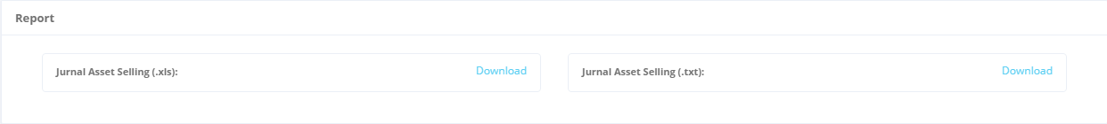

Figure 24: download template

The excel file is provided so that the PIC OPL can check the sales results that will be uploaded later in MFAPPL. If it is appropriate, proceed with the download file textfile, and then will be uploaded in MFAPPL.

Furthermore, there will be a process of journalizing asset selling, asset releases, and the release of BPKB documents for related assets processed at MFAPPL. If the three steps are already processed in MFAPPL, MFAPPL will send the status of the BPKB document and status to OLSS, where the investment return report and the submission memo will be changed to CLOSED, indicating the sales process has been completed.